Raw Material Asset Ledger (Fabric)
1. Add New Fabric Roll
- HTTP Method & Path: POST /api/manufacturing/fabric/add
- Payload Type: JSON @RequestBody Fabric fabric
- RBAC Clearance: OWNER, SUPER_ADMIN, ADMIN
- Under-the-Hood Workflow:
  - Intercepts incoming raw textile roll parameters (Material Type, Color, GSM, Total Kilograms).
  - Overwrites status variables to "STORED" and copies the totalKgs configuration directly onto your available balance column tracking vector (remainingKgs).
  - Persists the roll as an active inventory item row, making it available for production allocation.
2. Get All Fabric Inventory Stocks
- HTTP Method & Path: GET /api/manufacturing/fabrics
- Payload Type: None (Returns JSON Array of Fabric records)
- RBAC Clearance: OWNER, SUPER_ADMIN, ADMIN, EMPLOYEE
- Under-the-Hood Workflow:
  - Executes a broad query scanning your fabric repository.
  - Returns current raw material balances to the production dashboard, allowing floor staff to view fabric levels before creating new production lots.

The Production Lot Lifecycles (ProductionLot)
3. Create Production Lot & Allocate Fabric
- HTTP Method & Path: POST /api/manufacturing/lot/create
- Payload Type: JSON @RequestBody CreateLotRequest request
- RBAC Clearance: OWNER, SUPER_ADMIN, ADMIN
- Under-the-Hood Workflow:
  - Resolves the specified material roll using fabricId. Throws an exception if it is not found.
  - Stock Verification Check: Verifies that the fabric roll has enough available weight to handle the request:
$$\text{fabric.getRemainingKgs}() < \text{request.getFabricUsedKgs}()$$
If fabric is insufficient, it blocks creation to prevent paper allocations.
  - Deducts the allocated weight from the fabric inventory row immediately.
  - Generates a unique, high-speed tracking identifier string using the current timestamp prefix ("LOT-" + System.currentTimeMillis()).
  - Maps the incoming nested sizing allocations (S, M, L, XL) into individual relational child rows (LotItem), setting the default status tracking variable to "NEW".
4. Update Lot Status & Log Quality Control Rejections
- HTTP Method & Path: POST /api/manufacturing/lot/status
- Payload Type: JSON @RequestBody UpdateStatusRequest request
- RBAC Clearance: OWNER, SUPER_ADMIN, ADMIN, EMPLOYEE
- Under-the-Hood Workflow:
  - Pulls the target manufacturing lot record using the provided primary key ID value.
  - Advances the state parameter flag to the requested target setting (e.g., "CUTTING", "STITCHING", "COMPLETED").
  - Quality Control Evaluation Pass: Loops through the lot's individual size rows if the request contains a rejections mapping array. It calculates item rejections dynamically using an additive delta loop:
$$\text{RejectedQty} = \text{RejectedQty} + \text{newRejections}$$
$$\text{ProduceQty} = \text{PlannedQty} - \text{TotalRejectedQty}$$
  - Finalization Trigger: If the status crosses the "COMPLETED" threshold, the engine automatically runs lot.setCompletedDate(LocalDateTime.now()) to lock down processing speeds for performance audits.
5. Cancel Active Production Lot
- HTTP Method & Path: POST /api/manufacturing/lot/cancel/{id}
- Payload Type: URL Path Parameter {id}
- RBAC Clearance: OWNER, SUPER_ADMIN, ADMIN
- Under-the-Hood Workflow:
  - Loads the specified manufacturing lot into memory.
  - Safety Barrier Evaluation: Verifies if the lot status parameter reads "COMPLETED". If it does, the operation fails immediately to prevent historical data changes.
  - Changes the status flag tracking setting to "CANCELLED".
6. Multi-Variable Operational Filtering Matrix
- HTTP Method & Path: GET /api/manufacturing/lot/filter
- Payload Type: Optional Query Parameters (?status=X&startDateFrom=Y&startDateTo=Z&expDateFrom=A&expDateTo=B)
- RBAC Clearance: OWNER, SUPER_ADMIN, ADMIN, EMPLOYEE
- Under-the-Hood Workflow:
  - Evaluates incoming query date parameters and parses empty string elements to null cleanly.
  - Converts incoming calendar strings into exact boundaries using .atStartOfDay() for starting ranges and .atTime(LocalTime.MAX) for ending metrics.
  - Passes parameters directly into your database filter method to generate specific pipeline views for factory operations.

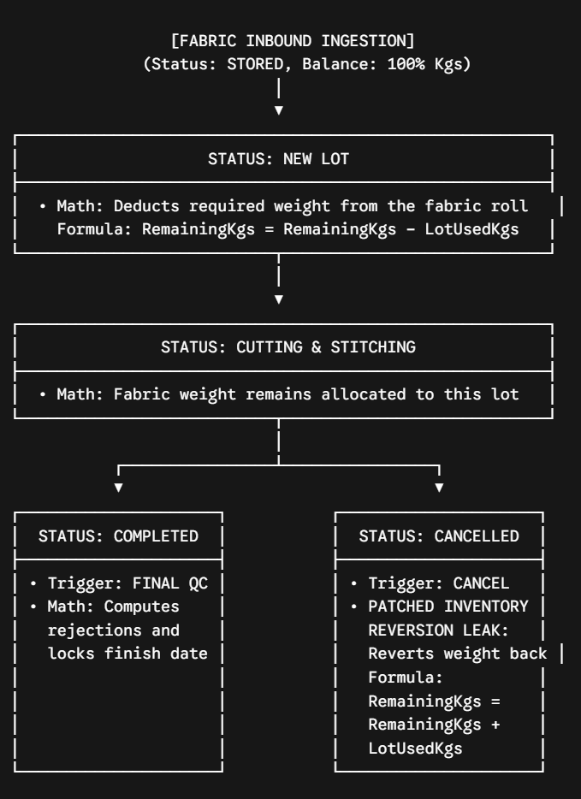
Lifecycle model demonstrates how data flows and state values update when moving a production run from raw fabric rolls to finished items
:

